PROG6212- ST10451478 - Khaya Nxumalo
Assignment 1

Documentation

Design choices
For the contract monthly claim system the design must be streamlined for the submission and approval of monthly claims for independent contractor lecturers.The system must be modular, scalable and comply with the separation of concerns principles, ensuring maintainability and extensibility.Troelsen, A. and Japikse, P. (2021)
The architectural pattern is an (Model-View-ViewModel)
- Model - represents domain entities and database schema
- View - XAML based user interface for user interaction
- ViewModel- Will handle user input,business logic and data flow

Technologies
- .Net Core WPF
- XAML
- ObservableCollection Troelsen, A. and Japikse, P. (2021)

GUI Layout (MVC razor views)
- Manager views
- Approval panel where final decision shown
- Audit trail access where view logs and supporting documents is

- Lecturer views
- Dashboard contains overview of submitted claims and statuses
- Submit claim form prompts for input hours,month and upload documents

- Coordinator views
- Claim detail view is the approve or reject with comments

The GUI layout contains validation,consistency and accessibility: layout is clear across all roles, input constraints and designed to be responsive for desktop and mobile.

Assumptions and constraints
Assumptions
- Claims are being submitted monthly and must be approved within the very same month
- Coordinators and managers have different roles and levels of access
- PDF and image files are the allowed document type for uploads
- Each lecturer has a fixed hourly rate
- Coordinators and Managers have distinct roles and access levels.
Constraints
- Authentication and authorization are assumed but have not been configured.
- Azure services are planned for but have not been implemented at this stage
- Backend logic or connection to the database have not been implemented at this stage

- UML class diagram for databases
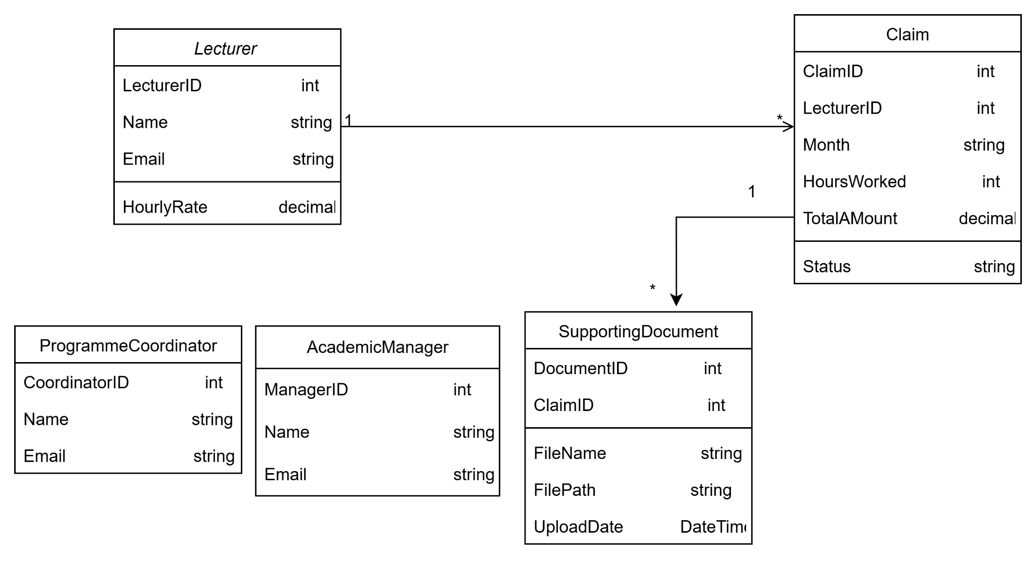
- Project plan

Phase | Task | Duration | Dependencies
1️ Requirements and planning | Analyze assignment brief, define scope | 1 day | None
2️ Database design | Create UML class diagram | 2 days | Phase 1
3️ Project setup | Initialize ASP.NET Core MVC project, configure folders | 1 day | Phase 2
4️ Model creation | Define C# classes for Lecturer, Claim, Document, etc. | 2 days | Phase 3
5️ View design | Create Razor views for Lecturer Dashboard, Claim Form, Admin Panels | 3 days | Phase 4
6️ Controller stubs | Add empty controllers for navigation and routing | 1 day | Phase 5
7️ UI styling | Apply Bootstrap for layout and responsiveness | 2 days | Phase 5
8️ Documentation | Write design rationale, assumptions, and constraints | 1 day | All phases
Final Review | Test navigation, validate layout, prepare submission | 1 day | All phases
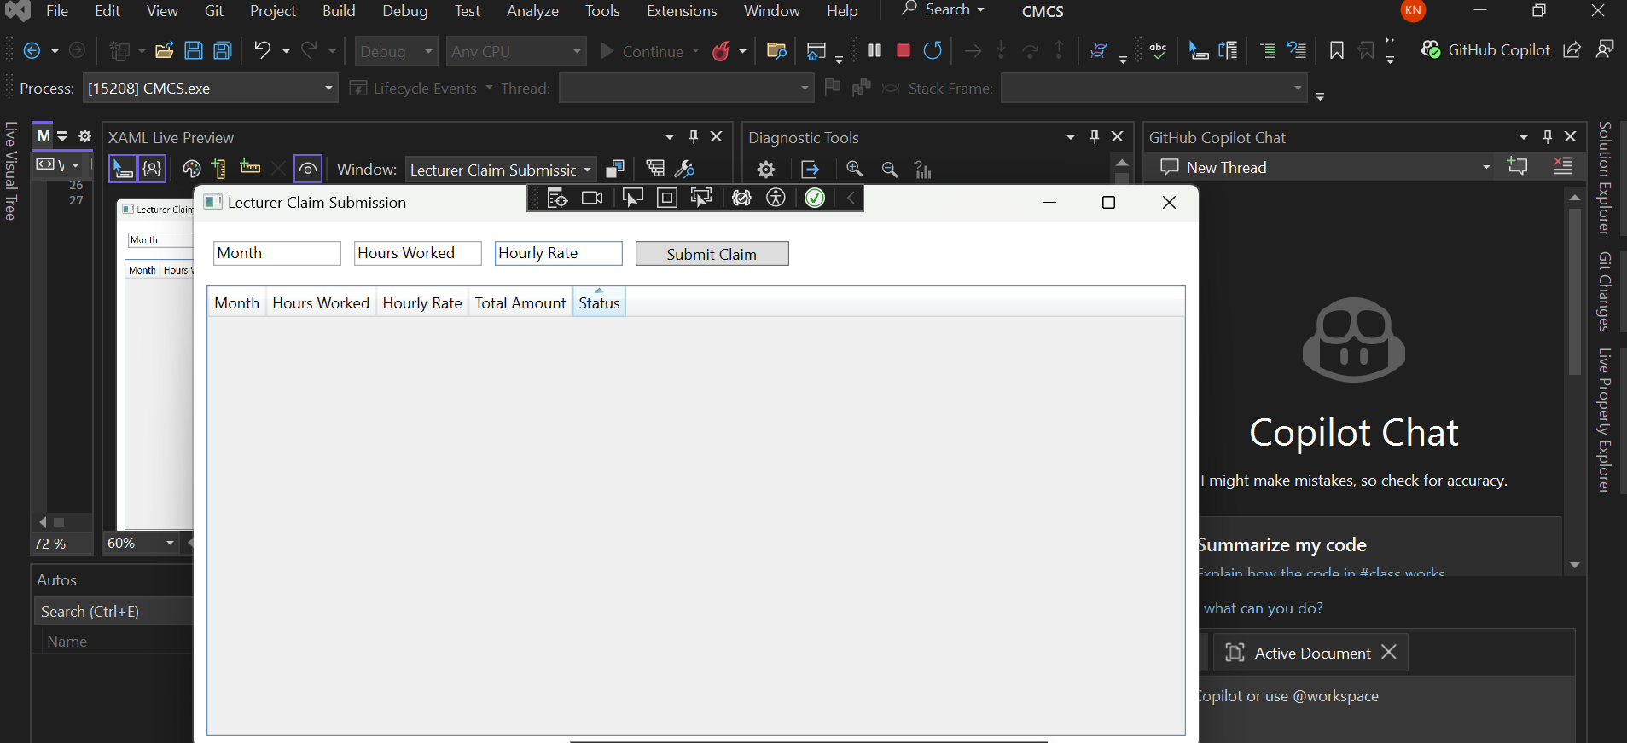
- GUI/UI

References
Troelsen, A. and Japikse, P. (2021). Pro C# 9 with .NET 5 : foundational principles and practices in programming. Berkeley, Ca: Apress L. P., . Copyright.

‌

